JAVA ASSIGNMENT- 02 (09-11-2018)

Unary operator programs:

Program-1(Predecrement):
class PreDecrement
{
public static void main(String args[])
{
int a=21;
int b=--a;
System.out.println("a:"+a);
System.out.println("b:"+b);
}
}
Output:
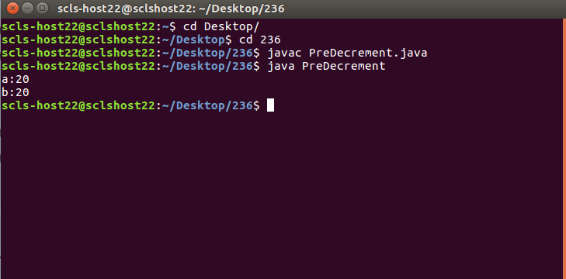

Program-2(Postdecrement):
class PostDecrement
{
public static void main(String args[])
{
int a=47;
int b=a--;
System.out.println("a:"+a);
System.out.println("b:"+b);
}
}
Output:
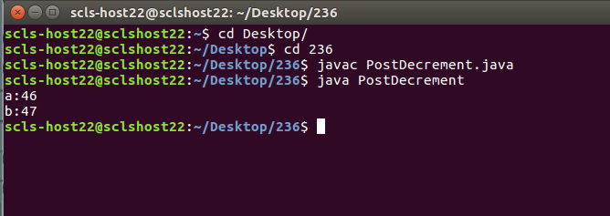

Program-3(Increment):

class Increment
{
public static void main(String args[])
{
int a=20;
int b=(++a)+(++a);
System.out.println("a:"+a);
System.out.println("b:"+b);
}
}
Output:
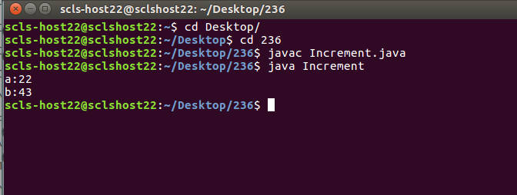

Program-4(Increment1):

class Increment1
{
public static void main(String args[])
{
int a=21;
int b=(a++)+(a++);
System.out.println("a:"+a);
System.out.println("b:"+b);
}
}
Output:
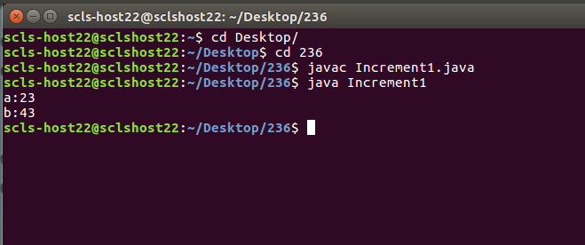

Program-5(Increment2):

class Increment2
{
public static void main(String args[])
{
int a=11;
int b=(a++)+(++a);
System.out.println("a:"+a);
System.out.println("b:"+b);
}
}
Output:
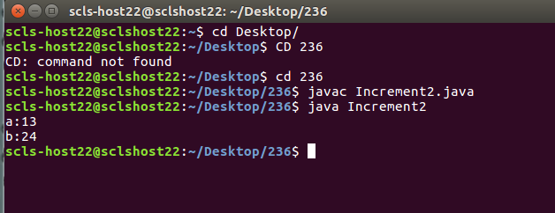

Program-6(Employedata):

class Employdata
{
int empno;
String name;
String town;
int basic;
float hra;
float da;

Employdata(int a,String b,String c,int d,float e,float f)
{
empno=a;
name=b;
town=c;
basic=d;
hra=e;
da=f;

}
void EmployNo1()
{
System.out.println("Empno:"+empno);
System.out.println("Name:"+name);
System.out.println("Town:"+town);
System.out.println("Basic:"+basic);
System.out.println("Hra:"+hra);
System.out.println("Da:"+da);
System.out.println("salary:"+(basic+hra+da));
System.out.println("-----------------------------------------------------------");
}
void EmployNo2()
{
System.out.println("Empno:"+empno);
System.out.println("Name:"+name);
System.out.println("Town:"+town);
System.out.println("Basic:"+basic);
System.out.println("Hra:"+hra);
System.out.println("Da:"+da);
System.out.println("salary:"+(basic+hra+da));
System.out.println("-----------------------------------------------------------");
}
void EmployNo3()
{
System.out.println("Empno:"+empno);
System.out.println("Name:"+name);
System.out.println("Town:"+town);
System.out.println("Basic:"+basic);
System.out.println("Hra:"+hra);
System.out.println("Da:"+da);
System.out.println("salary:"+(basic+hra+da));
System.out.println("-----------------------------------------------------------");
}
}
class TestEmploydata
{
public static void main(String args[])
{
Employdata obj1=new Employdata(236,"Rajashekar","Warangal",20000,3000,2000);
obj1.EmployNo1();

Employdata obj2=new Employdata(237,"Harish","Hyderabad",30000,4500,3000);
obj2.EmployNo2();

Employdata obj3=new Employdata(238,"Kalyan","Nalgonda",40000,6000,4000);
obj3.EmployNo3();
}
}
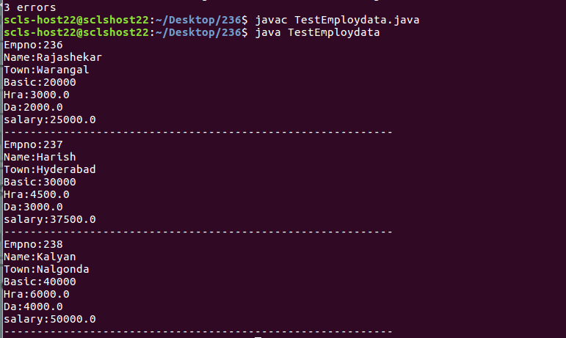

Program-7(TestEmploydata2):

class Employdata
{
int empno;
String name;
String town;
float basic;
float hra;
float da;

Employdata(int a,String b,String c,float d)
{
empno=a;
name=b;
town=c;
basic=d;

}
void EmployNo1()
{
hra=basic*15/100;
da=basic*10/100;
System.out.println("Empno:"+empno);
System.out.println("Name:"+name);
System.out.println("Town:"+town);
System.out.println("Basic:"+basic);
System.out.println("Hra:"+hra);
System.out.println("Da:"+da);
System.out.println("salary:"+(basic+hra+da));
System.out.println("-----------------------------------------------------------");
}
void EmployNo2()
{
hra=basic*15/100;
da=basic*10/100;
System.out.println("Empno:"+empno);
System.out.println("Name:"+name);
System.out.println("Town:"+town);
System.out.println("Basic:"+basic);
System.out.println("Hra:"+hra);
System.out.println("Da:"+da);
System.out.println("salary:"+(basic+hra+da));
System.out.println("-----------------------------------------------------------");
}
void EmployNo3()
{
hra=basic*15/100;
da=basic*10/100;
System.out.println("Empno:"+empno);
System.out.println("Name:"+name);
System.out.println("Town:"+town);
System.out.println("Basic:"+basic);
System.out.println("Hra:"+hra);
System.out.println("Da:"+da);
System.out.println("salary:"+(basic+hra+da));
System.out.println("-----------------------------------------------------------");
}
}
class TestEmploydata2
{
public static void main(String args[])
{
Employdata obj1=new Employdata(236,"Rajashekar","Warangal",20000);
obj1.EmployNo1();

Employdata obj2=new Employdata(237,"Harish","Hyderabad",30000);
obj2.EmployNo2();

Employdata obj3=new Employdata(238,"Kalyan","Nalgonda",40000);
obj3.EmployNo3();
}
}
Output:
